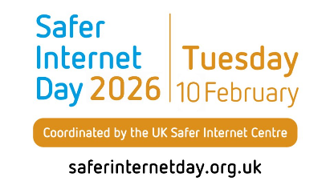
What is Safer Internet Day?
On Tuesday 10th February 2026 we will join schools and youth settings across the UK in celebrating Safer Internet Day 2026. Safer Internet Day is the UK’s biggest celebration of online safety. It is celebrated globally in February each year to promote the safe and positive use of digital technology for children and young people, and to inspire a national conversation about using technology responsibly, respectfully, critically, and creatively.
Using the internet safely and positively is a key message that we promote in school, and celebrating Safer Internet Day is a great opportunity for us to re-emphasise the online safety messages we deliver throughout the year.
Top tips for parents
- Enjoy going online together.
Spending time online together with family is an important learning experience for the youngest internet users. Not only will you both enjoy the quality time together, but you can supervise their usage and guide them to make the safest choices.
- Talk about their online experiences.

Help give your child the words to explain what they’re experiencing online by starting conversations
about the internet and technology as early as possible. Talking regularly about what they love doing
online, as well as any worries they may have, will help establish this habit and mean they’re more
likely to come to you for help as they get older.
#

- Make use of settings and control.

Parental controls and other safety settings can help protect your child from online harms,
including upsetting or inappropriate content. Think about how your child uses technology, for example, if you
have a smart TV or a voice assistant at home, and explore specific settings to support your household.
Adult supervision for children using the internet, especially under 5s, is crucial.

- Make sure they know that they can always come to you.

The most important thing for your child to know is that you are always there to support them,
online and offline. Encourage them to talk to you if anything they experience makes them feel
worried or upset, and show them they can trust you to stay calm, listen and help make things better.

Clink on the links below for further information.
Keep Children Safe Online: Information, advice, support - Internet Matters
RECOMMENDED! The one-stop-shop for information and advice for keeping children safe online.
https://www.askaboutgames.com
Advice and online guides about gaming and PEGI age ratings.
https://www.familygamingdatabase.com
Information presented for parents and carers to find games suitable for children, teenagers and young adults.
https://www.ceopeducation.co.uk/parents
Helping you to better protect your children online.

